
AGED CARE RESOURCES & SERVICES:
LICENSE AGREEMENT – 9 July 2025

Gevers Goddard Jones Pty Ltd trading as GGJ Consultants  ABN: 44 100 066 957  31 Tuckfield Street, Fremantle WA 6160  Email: RESOURCES@GGJ.COM.AU Phone: 0407 197 992 | GGJ Bank Details: | BSB: 086 217  Account No: 54 300 6476  Please include Invoice Number in Bank Payment

Purchaser*

Name:  Address: | ABN / ACN / IAN:  Email:  Telephone:
Entity Type: ☐ Association/ NFP ☐ Company Ltd by Guarantee ☐ Aboriginal Corporation ☐ Pty Ltd Company ☐ LGA
Please indicate: ☐ Approved Provider ☐ CHSP Service Provider ☐ Consultant ☐ Franchisee

RACS ID Number/s:

Key Contact  Name:  Position:  Email:  Telephone: | Invoicing Contact  Name:  Position:  Email:  Telephone:
Signed as an agreement inclusive of below aged care resources & services terms & conditions for and on behalf of the *Purchaser by its duly authorised representative:
PURCHASER: Name, Position and Signature  Date: | GGJ REPRESENTATIVE: Leslie Gevers, Director  Date:
See pages 2 to 6 below for GGJ Aged Care Resources & Services Terms & Conditions (Version 1.04).
Additional Contacts:

GGJ ORDER FORM – 9 July 2025
ORDER | DETAILS | QTY | COST | TOTAL
1. 2024 EXAMPLE POLICIES AND PROCEDURES – HOME CARE
Example Policies and Procedures and Forms for Home Care | CHSP Only - Registration categories 1-3: License for one outlet  (Note $200 discount on Annual Support Subscription – see below) |  | $3,500.00
Example Policies and Procedures and Forms for Home Care | CHSP Only - Registration categories 4-6: License for one outlet |  | $4,500.00
Example Policies and Procedures and Forms for Home Care | HCP Only: License for one outlet |  | $6,000.00
Example Policies and Procedures and Forms for Home Care | CHSP and HCP: License for one outlet |  | $6,500.00
Example Policies and Procedures and Forms for Home Care | License for additional outlets (RACS ID) |  | $250.00
Example Policies and Procedures and Forms for Home Care | Annual Support Subscription – Updates for Policies and Procedures (NOT State legislation)* |  | $800.00
Example Policies and Procedures and Forms for Home Care | Support fee per additional outlet |  | $150.00
2. 2024 EXAMPLE POLICIES AND PROCEDURES MANUAL – RESIDENTIAL CARE
Example Policies and Procedures and Forms for Residential Care | Residential Care: License for one outlet |  | $8,000.00
 | License for additional outlets (RACS ID) |  | $300.00
 | Annual Support Subscription – Updates for Policies and Procedures (NOT State legislation)* |  | $1,000.00
 | Support fee per additional outlet |  | $250.00
3. 2024 EXAMPLE POLICIES AND PROCEDURES MANUAL – INTEGRATED HOME CARE AND RESIDENTIAL CARE
Example Policies and Procedures and Forms for Integrated Home Care and Residential Care | Integrated Home Care and Residential Care: License for one outlet.  For Home Care Select: CHSP HCP Both |  | $10,000.00
 | License for each additional outlet (RACS ID) |  | $500.00
 | Annual Support Subscription – Updates for Policies and Procedures (NOT State legislation)* |  | $1,500.00
 | Support fee per additional outlet |  | $300.00
4. ADDITIONAL CUSTOMISATION SERVICES FOR EXAMPLE POLICIES AND PROCEDURES MANUALS
Customisation Options for the Policies and Procedures | Inclusion of your logo and service name in the P&P and forms |  | $600.00
Customisation Options for the Policies and Procedures | Change Example Worker Positions to your Organisation Positions. (You need to complete the Attached Positions Form.) |  | $1500.00
Customisation Options for the Policies and Procedures | Change legislation references in the Policies and Procedures (not Forms) to your State or Territory (Not required for WA) |  | $900.00
Customisation Options for the Policies and Procedures | State-Specific Content Support Subscription. - Content will be audited twice per year. A summary of the audit, and any required changes, will be provided. (All States and Territories) |  | $375.00 per State
6. 2024 AUDIT AND SURVEY TOOLS: (Requires Microsoft Word and Excel 2007 or newer) - (Double Prices for non-P&P Purchasers)
Audit and Survey Tools for Home Care | License for one outlet |  | $1200.00
Audit and Survey Tools for Home Care | License for each additional outlet |  | $100.00 ea.
Audit and Survey Tools for Residential Care | License for one outlet |  | $1,400.00
Audit and Survey Tools for Residential Care | License for additional outlets |  | $100.00 ea.
Audit and Survey Tools for Integrated Service | License for one outlet |  | $1,600.00
Audit and Survey Tools for Integrated Service | License for additional outlets |  | $100.00 ea.
7. 2024 NDIS ADD-ON: Inclusion of the NDIS Standards requirements in the Aged Care Policies and Procedures
Covers the Core Module of NDIS Standards | License covers multiple outlets. The Add-on applies to Home Care and Residential Care |  | $3,250.00
NDIS Core Module Updates | Annual Support subscription - Content will be audited twice per year and any required changes, will be provided. |  | $600.00
8. SERVICE AGREEMENTS
Service Agreement for Home or Residential Care | We recommend the Service Agreement from Aged Care Provider Assistance. Isabelle Kimler 0406 536 743
TOTAL FEES (EXCLUDING GST)
TOTAL FEES (INCLUDING GST)
*Note: If support is not purchased at the time of purchasing your P&P and you wish to purchase it in the future, you will need to pay for any periods where payment was not made to receive the updates for those periods.

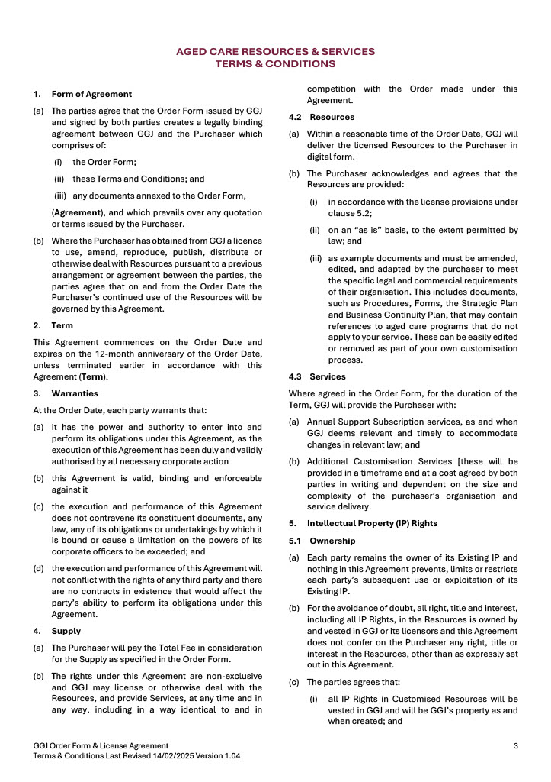

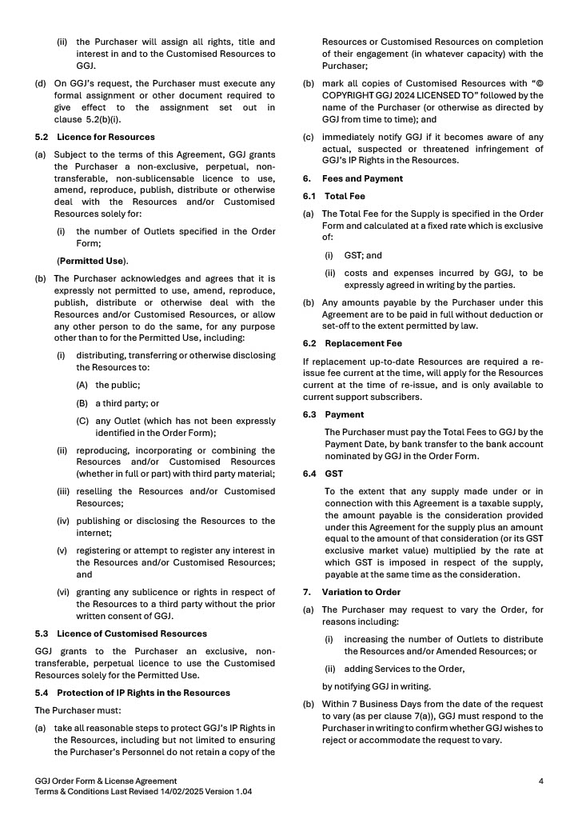

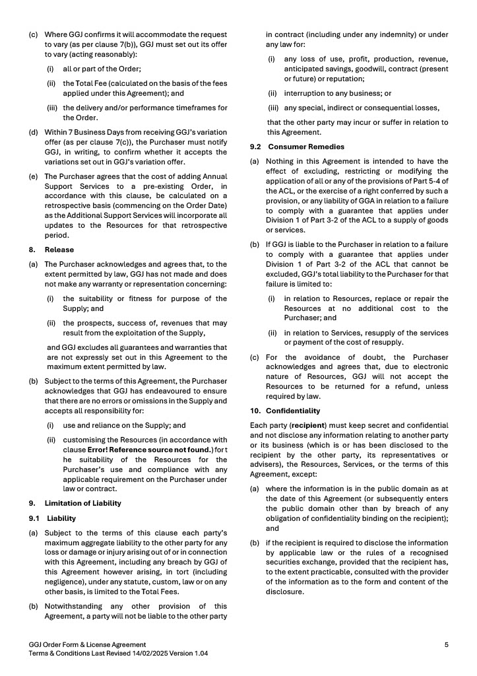

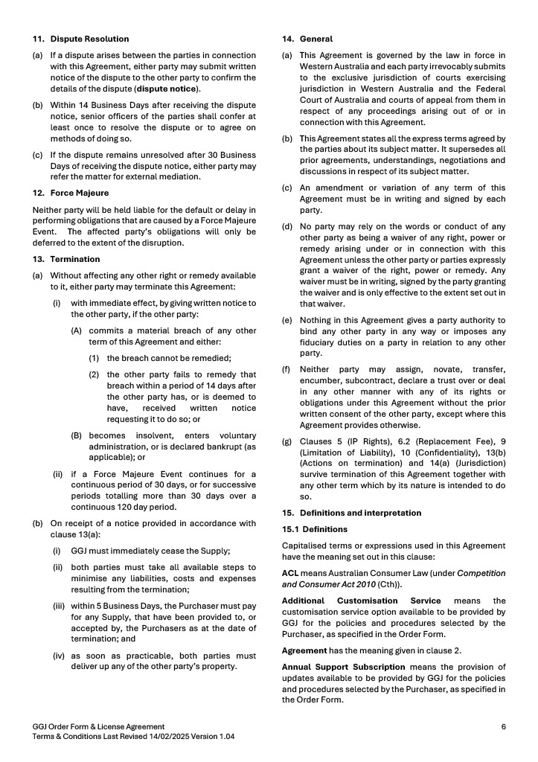

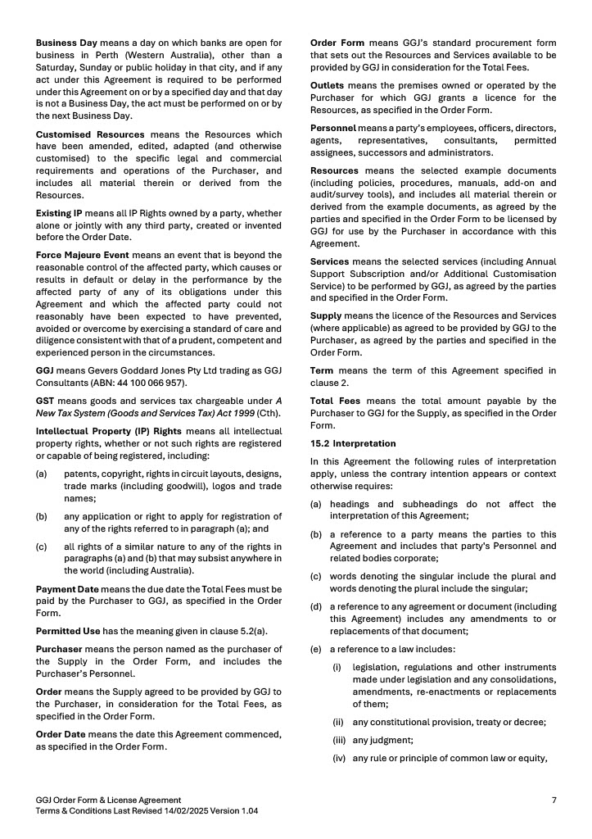

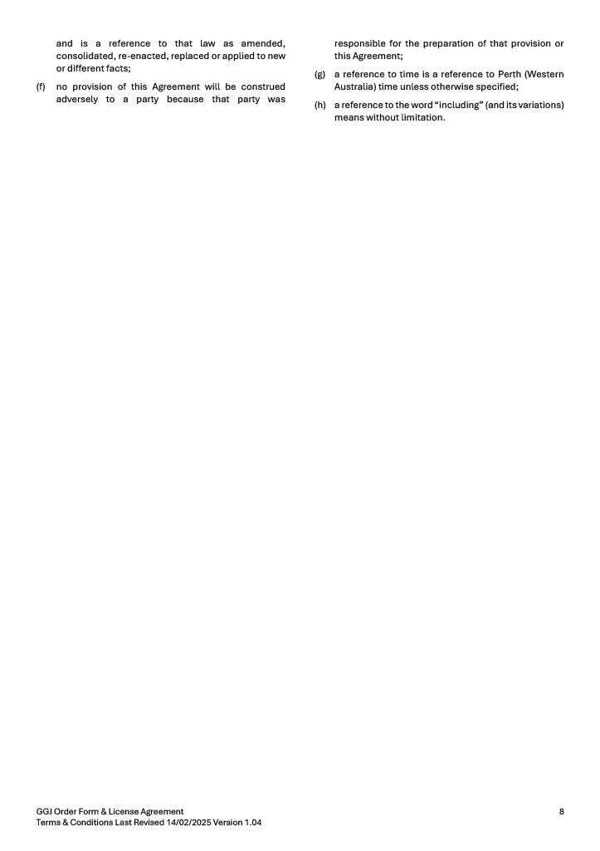

Note: We have updated our terms and conditions to ensure the expectations and responsibilities of purchasers and GGJ Consultants are clearly articulated. This update also ensures our terms and conditions comply with the changes to Australian Consumer Law regarding unfair contract terms. The amendments to the legislation (which commenced on 9 November 2023) mean that using (or even proposing) terms in standard form consumer contracts, that fall within the meaning of “unfair”, is now illegal and may attract substantial penalties.

